CSCI-GA.2434-001 Advanced Database Systems Dec 04th, 2016
Project Code Structure (final)
Yanghui Zhuang, N16904649; Di Hou, N14316306 Due: Tuesday, Dec 06th
Code Structure and Component Relation Illustration
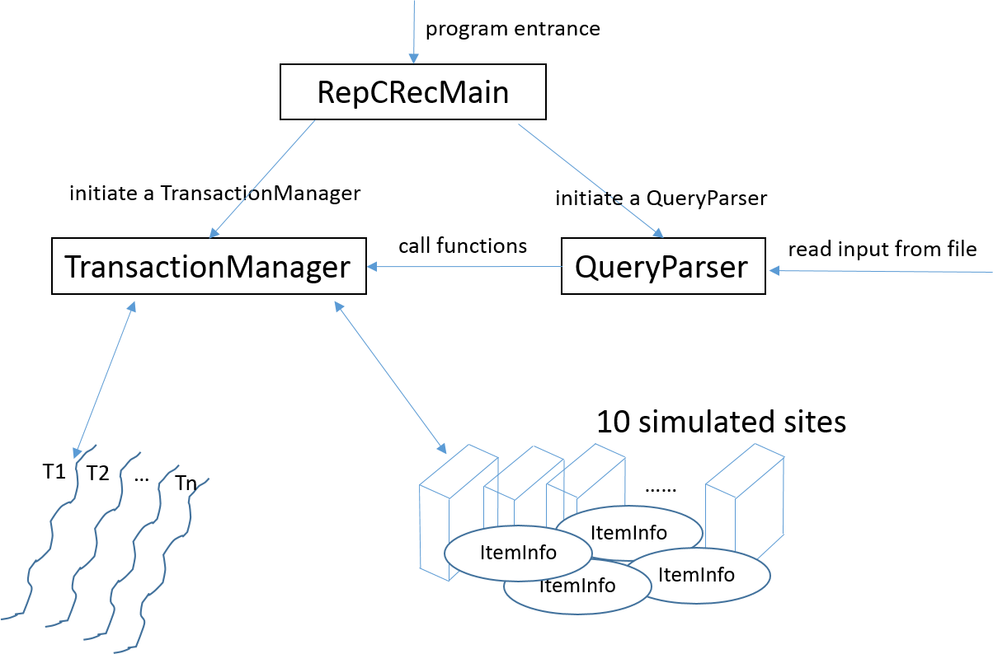
Code Structure Description
This replicated concurrency control and recovery database consists of 6 main parts, RepCRecMain.java, QueryParser.java, TransactionManager.java, Transaction.java, SimulatedSite.java, ItemInfo.java
● RepCRecMain, the entrance of the program, it does only two things:
– initialize a QueryParser
– initialize a TransactionManager.
● QueryParser
– parse user input and call methods in TransactionManager
– check and execute unfinished query first when the logical time advanced
– call deadLockCheckAndHandle() after a read / write query
● TransactionManager, the central control of the program.
– initialize the cluster (simulated sites)
– create a transaction when it receives “begin()” or “beginRO()”
– handle all commands from QueryParser, with the help of different transactions.
● Transaction, the executing thread, one thread for each transaction.
– create a database snapshot when a readonly transaction is initialized
– perform commitReadsAndWrites() and releaseLocks()
● SimulatedSite, the site actually store the data and perform certain operations on data
– use a lockTable to manager locks of different items
– accept updateConflicts() / dump() / fail() / recover() / commands from TransactionManager
● ItemInfo, stores all information about an item, with relative method to operate the item
– stores lock information and wait list information about this item
– provide any lock information about the item
– perform a critical operation, updateItemLockStatus()

Evolution
Program structure is changed from multi-threaded to single-threaded.

